**VEHICLE PARKING MANAGEMENT SYSTEM**

**ERD DIAGRAM**

**CLASS DIAGRAM**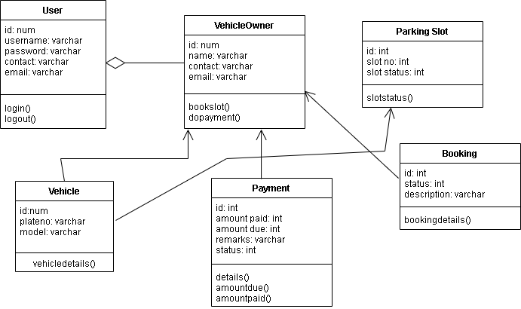

**SYSTEM FLOW DIAGRAM  
